Final design
- Changed parts from last report
  - state machine
Add three more states. First add the init state to deal with initialization, second to deal with the signal delay of d flipflop, three is deal to the separation of original state(P←p+b).They’re ‘init’, ‘loadPholdA2’ and ‘dataready’. The state diagram is shown below.
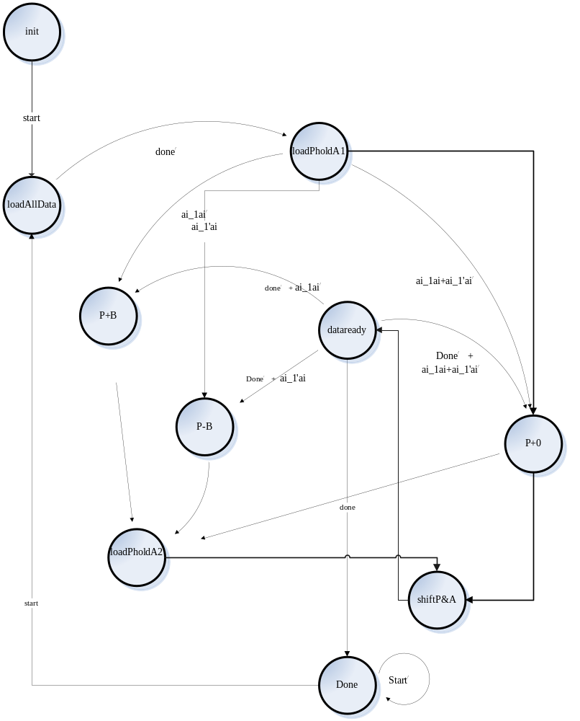
Addition to the changes made above, there are several signals add between the controller and datapath. They’re ‘set’ , ‘en’, ‘loadWhichP’, ‘resetDff’ and count.
Signal ‘set’ is used in the ‘init’ state to initialize the counter.
Signal ‘en’ is used to control when the adder will work.
Signal ‘loadWhichP’ is used for loading different p at different state.
Singnal ‘resetDff’’ is used to let a-1 equals to 0 at the first place.
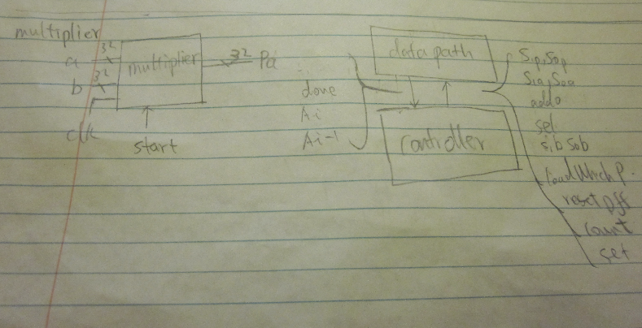
en
Therefore there are some changes in the block diagram too.
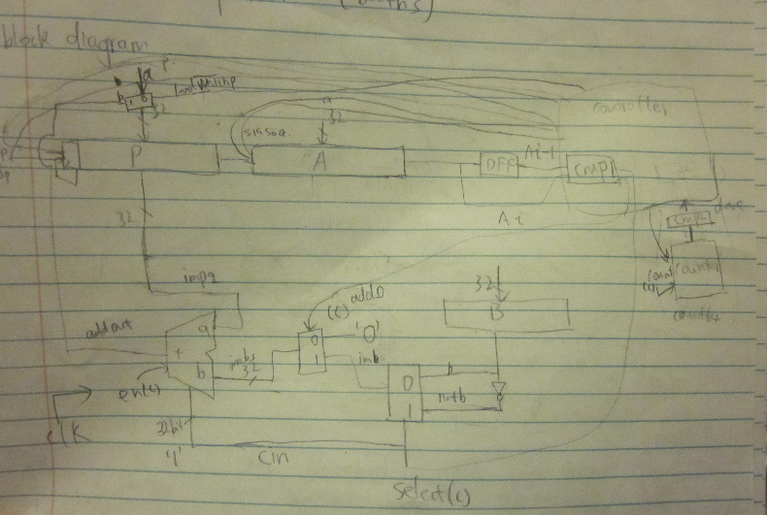
S1p
S0p
set
resetDff
  - tff and binary counter
Because in the ‘init’ state, the counter need to reset to 63 then count down. So the binary counter requires the tff have “set” function. In addition the binary counter needs another control signal ‘count’ too.

1.2.1 tff
Code
entity tff_withset is
port( t,clk,rstb,set : in bit;
q : out bit);
end entity;

architecture dataflow of tff_withset is

signal im_t : bit;

begin
p0: process(clk,set)
begin
if(set = '1') then
q <= '1';
im_t <= '1';
elsif(rstb = '0') then
q <= '0';
im_t <= '0';
elsif(t = '1'and clk='1' and not clk'stable) then
q <= not im_t;
im_t <= not im_t;
else null;
end if;
end process p0;

end dataflow;

testbench
entity tff_withset_tb is
end entity;

architecture io of tff_withset_tb is
component tff_withset is
port( t,clk,rstb,set : in bit;
q : out bit);
end component;

signal t,clk,rstb,set,q : bit;

for all: tff_withset use entity work.tff_withset(dataflow);

begin
c1: tff_withset port map(t,clk,rstb,set,q);

clk <= not clk after 10ns;
t <= not t after 18ns;
rstb <= '0', '1' after 20ns;
set <= '0', '1' after 60ns,'0' after 65ns, '1' after 85ns;
end io;

waveform
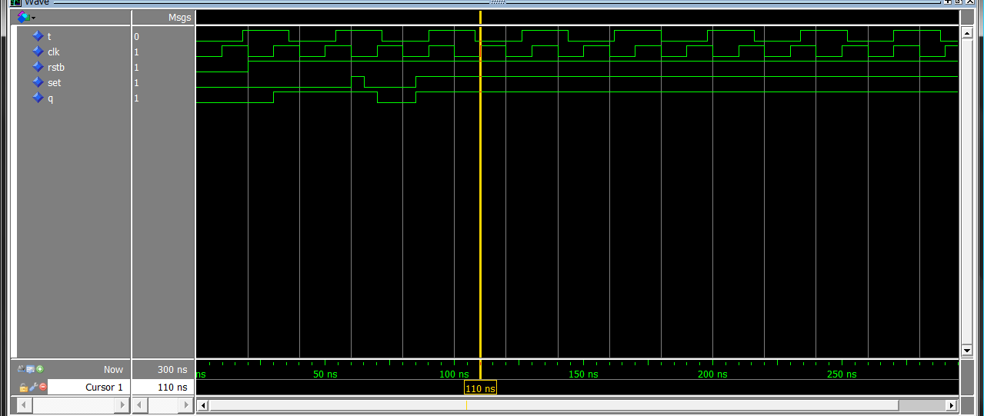
1.2.2 binary counter
Code
entity binary_counter_64 is
port(clk,set,count : in bit;
o : out bit_vector(5 downto 0));
end entity;

architecture struct of binary_counter_64 is
component tff_withset is
port( t,clk,rstb,set : in bit;
q : out bit);
end component;

for all: tff_withset use entity work.tff_withset(dataflow);
signal im : bit_vector (5 downto 0);
signal rstb : bit := '1';

begin
c1: tff_withset port map(count,clk,rstb,set,im(0));
c2: tff_withset port map(count,im(0),rstb,set,im(1));
c3: tff_withset port map(count,im(1),rstb,set,im(2));
c4: tff_withset port map(count,im(2),rstb,set,im(3));
c5: tff_withset port map(count,im(3),rstb,set,im(4));
c6: tff_withset port map(count,im(4),rstb,set,im(5));

o <= im;
end struct;
Testbench
entity binary_counter_64_tb is
end entity;

architecture io of binary_counter_64_tb is
component binary_counter_64 is
port(clk, set,count : in bit;
o : out bit_vector(5 downto 0));
end component;

for all: binary_counter_64 use entity work.binary_counter_64(struct);

signal o : bit_vector(5 downto 0);
signal clk, count,set : bit;

begin
c1: binary_counter_64 port map(clk,set,count,o);

clk <= not clk after 20ns;
count <= not count after 20ns;
set <= '0','1' after 100ns, '0' after 160ns, '1' after 280 ns, '0' after 300ns;

end io;

Waveform
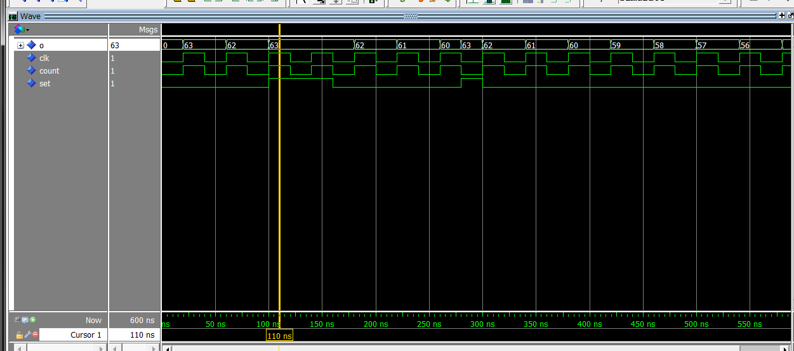

- booth multiplier
code
entity booth_multiplier32 is
port(a, b : in bit_vector(31 downto 0);
clk, start: in bit;
pa_p : out bit_vector(31 downto 0);
pa_a : out bit_vector(31 downto 0));
end entity;

architecture struct of booth_multiplier32 is
component controller_for_booth_multiplier is
port (start, done, ai, ai_1, clk, rstbController : in bit;
sp, sa, sb : out bit_vector(1 downto 0);
add0, sel, loadWhichP, count, resetDff,en,set : out bit);
end component;

component datapath_multiplier is
port (sp, sa, sb : in bit_vector(1 downto 0);
p,a,b: in bit_vector(31 downto 0);
pa_p,pa_a: out bit_vector(31 downto 0);
add0, sel, loadWhichP, resetDff, count,clk,en,set : in bit;
done, ai, ai_1, rstbController : out bit);
end component;

for all: controller_for_booth_multiplier use entity work.controller_for_booth_multiplier(behaviour);
for all: datapath_multiplier use entity work.datapath_multiplier(struct);

signal done, ai, ai_1,rstbController : bit := '1';
signal sp, sa, sb : bit_vector(1 downto 0);
signal add0, sel, loadWhichP, count, resetDff,en,set : bit;
signal p : bit_vector(31 downto 0);

begin
c1: controller_for_booth_multiplier port map(start, done, ai, ai_1, clk, '1', sp, sa, sb,add0, sel, loadWhichP, count, resetDff,en,set);
c2: datapath_multiplier port map(sp,sa,sb,p,a,b,pa_p,pa_a,add0, sel, loadWhichP, resetDff, count,clk,en,set,done, ai, ai_1, rstbController);

end struct;

testbench
entity booth_multiplier32_tb is
end entity;

architecture io of booth_multiplier32_tb is
component booth_multiplier32 is
port(a, b : in bit_vector(31 downto 0);
clk, start: in bit;
pa_p : out bit_vector(31 downto 0);
pa_a : out bit_vector(31 downto 0));
end component;

for all: booth_multiplier32 use entity work.booth_multiplier32(struct);

signal a, b : bit_vector(31 downto 0);
signal clk, start: bit;
signal pa_p : bit_vector(31 downto 0);
signal pa_a : bit_vector(31 downto 0);

begin
c1: booth_multiplier32 port map(a,b,clk,start,pa_p,pa_a);

a <= "11111111111111111111111111111111";
b <= "11111111111111111111111111111111";
clk <= not clk after 100ns;
start <= '0', '1' after 10ns, '0' after 500ns;
end io;

testcases(here use 5 testcases)
- -1 * -1 (negative number * negative number)
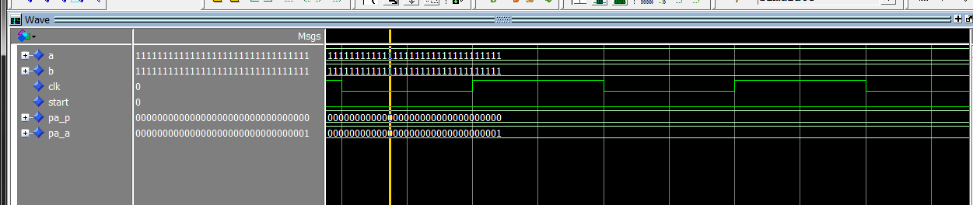
- -1 * 2(negative number * positive number)
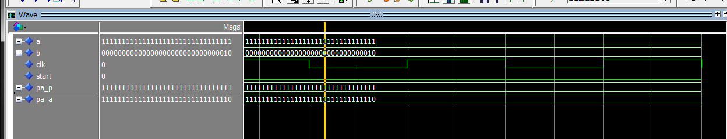
- 2 * 4(positive number * positive number)
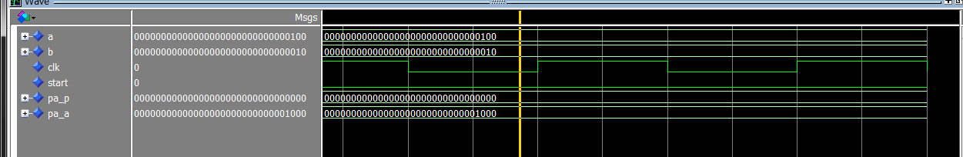
- -1 * 0(negative number * 0)
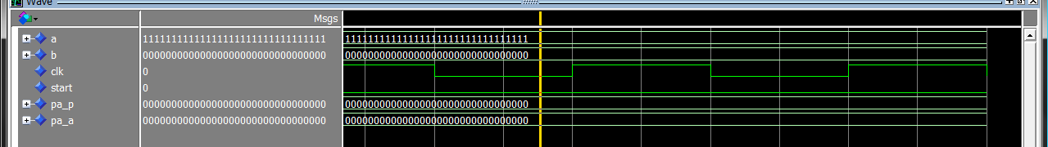
5. 1*0(positive number * 0)
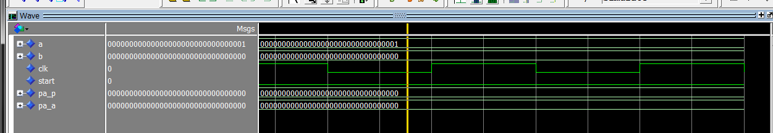

5.2147483647*2147483647(bignumber)
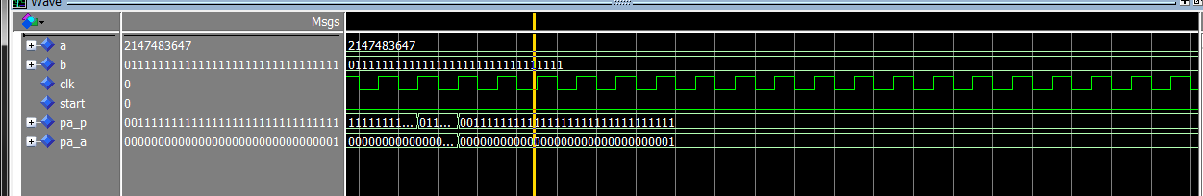
7. -2147483648 * -21474836478(smallest number)
